MANGINSAY, Eulan Angelika R.

2-ECE-E

**PROBLEM 1:**

**a.)**

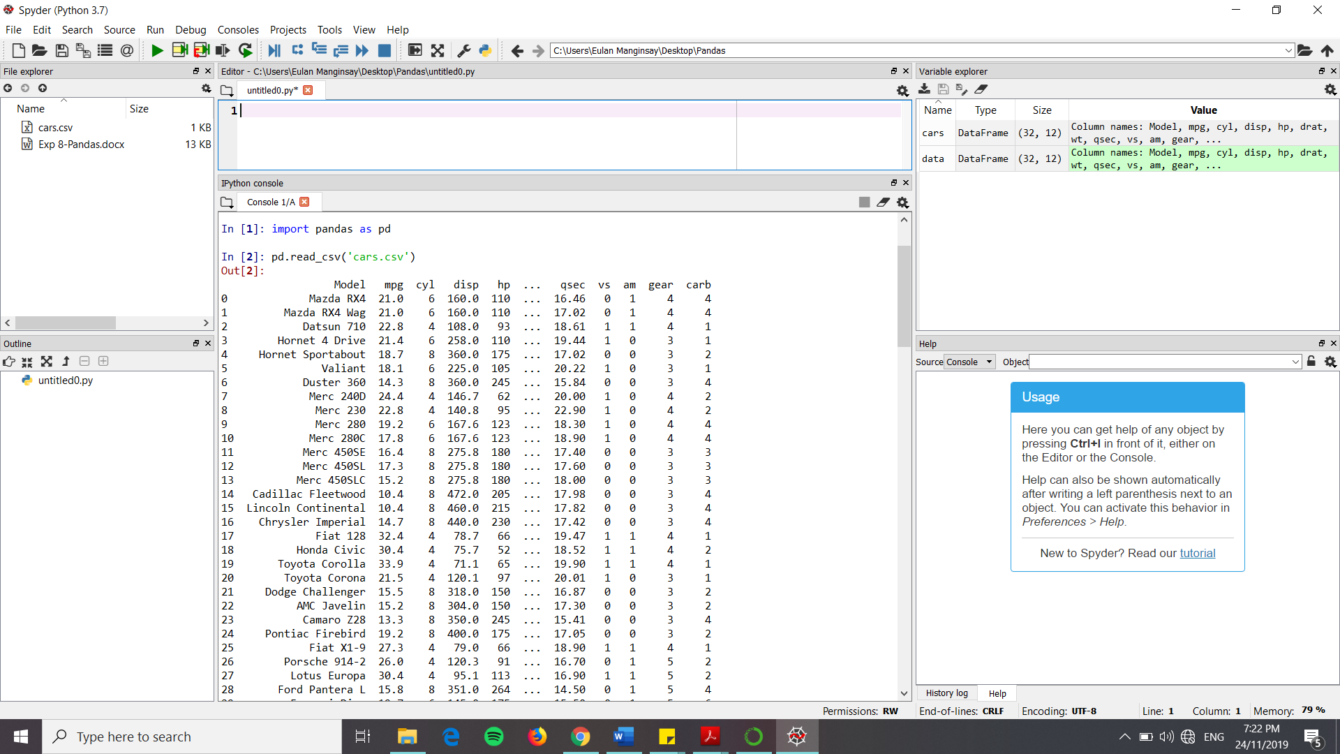

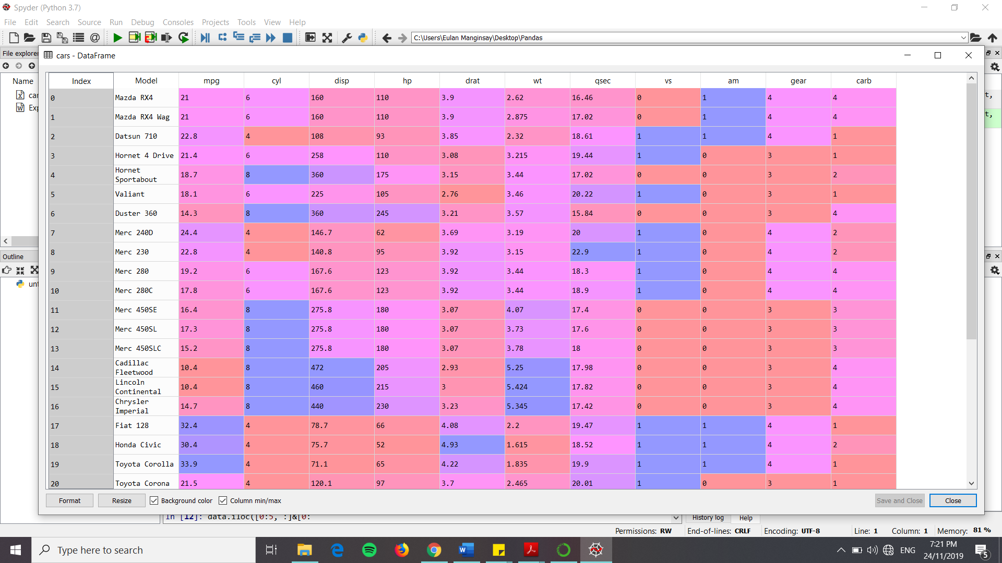

**b.)**

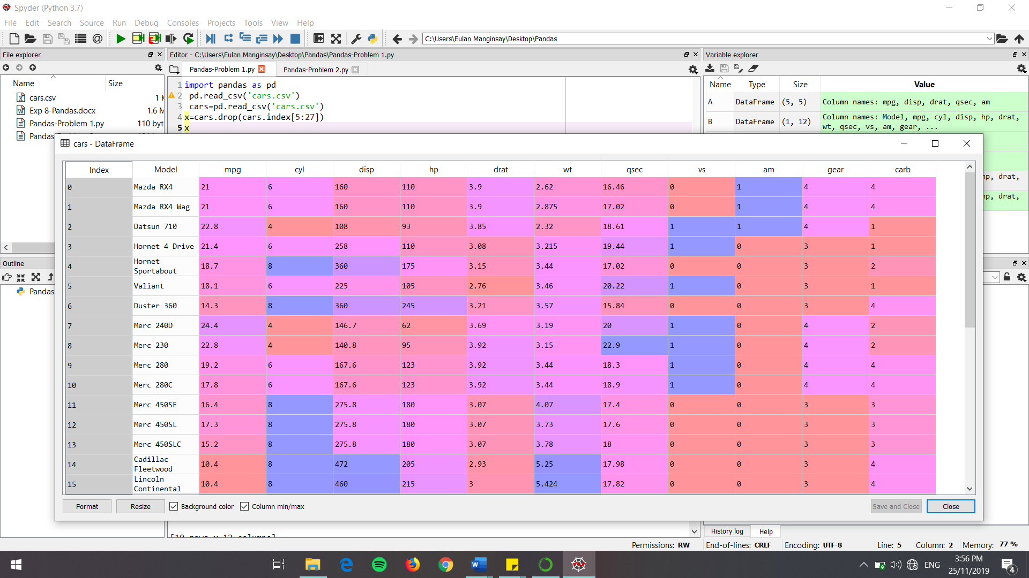

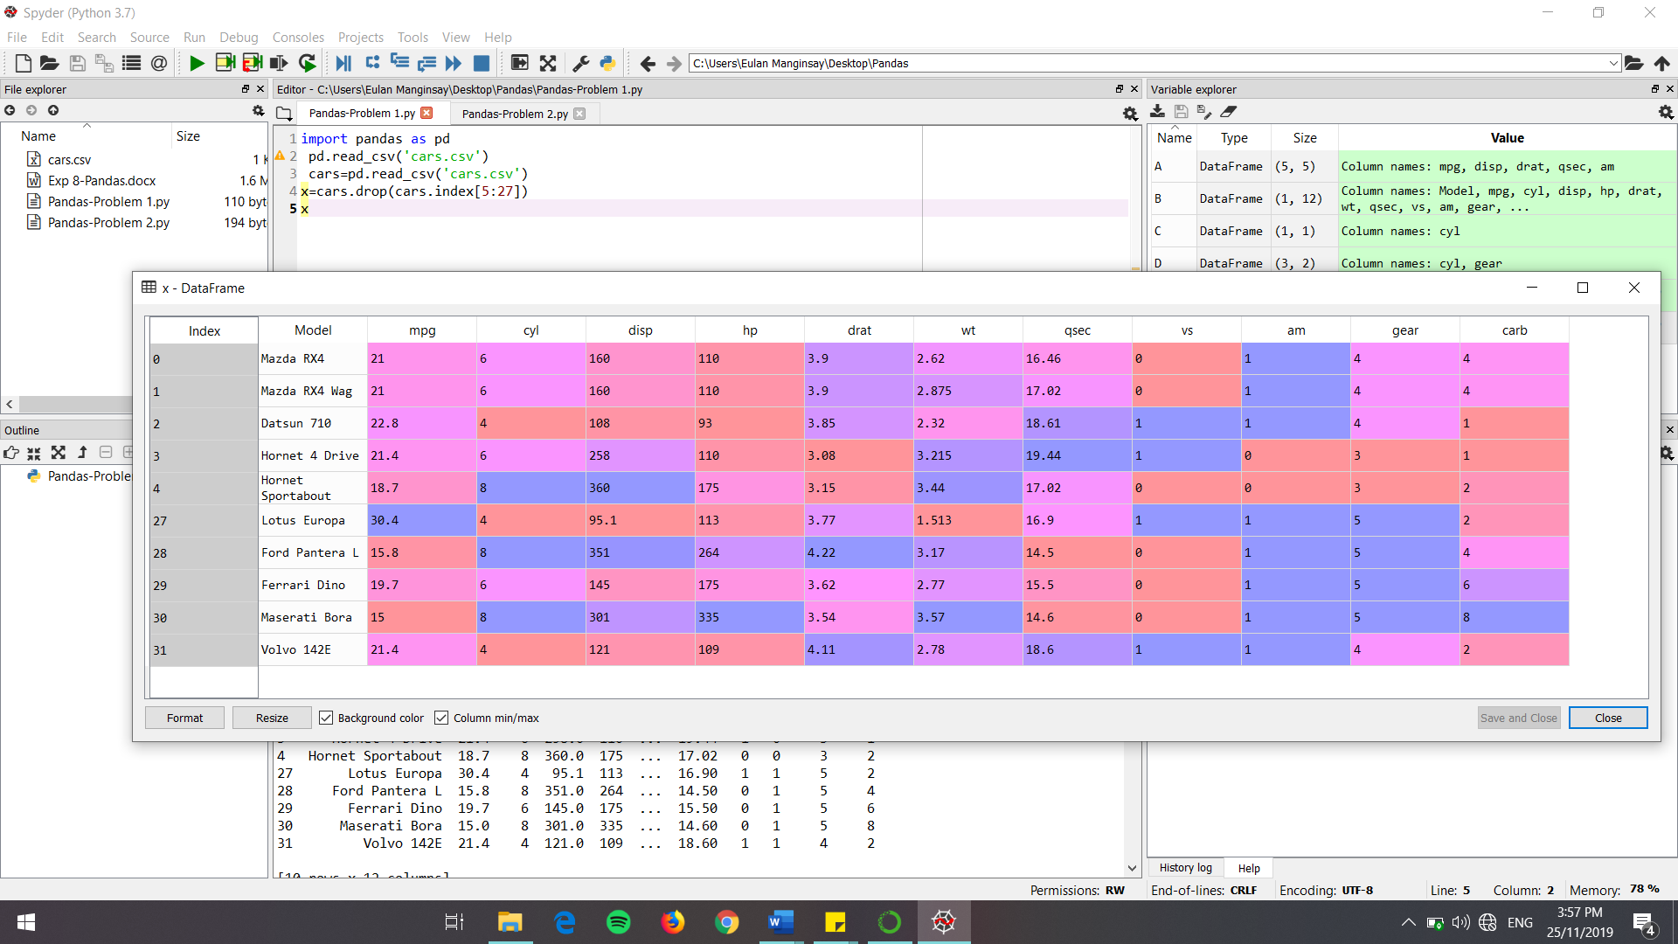

**PROBLEM 2:**

**a.)**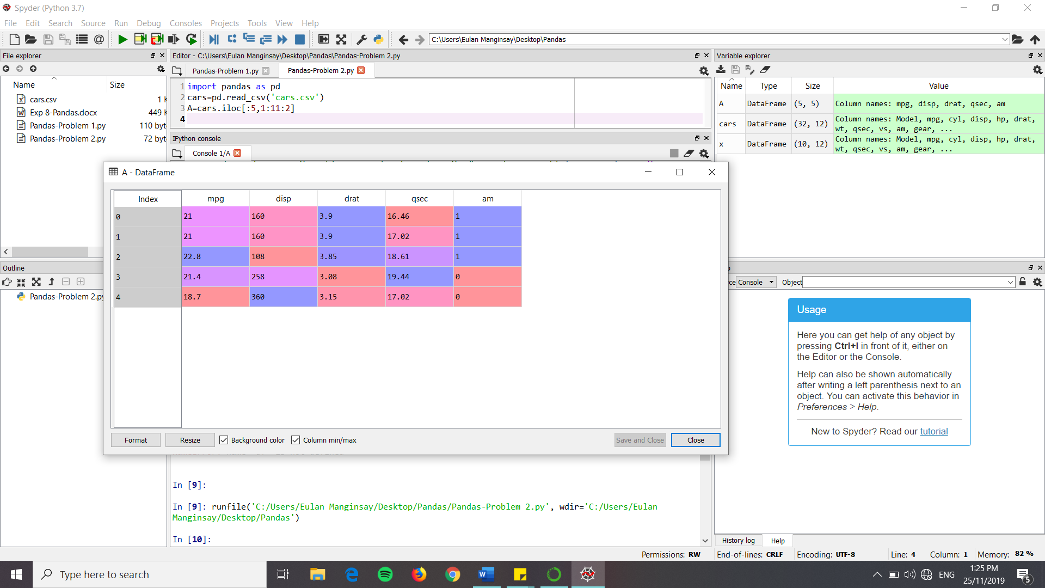

**b.)**

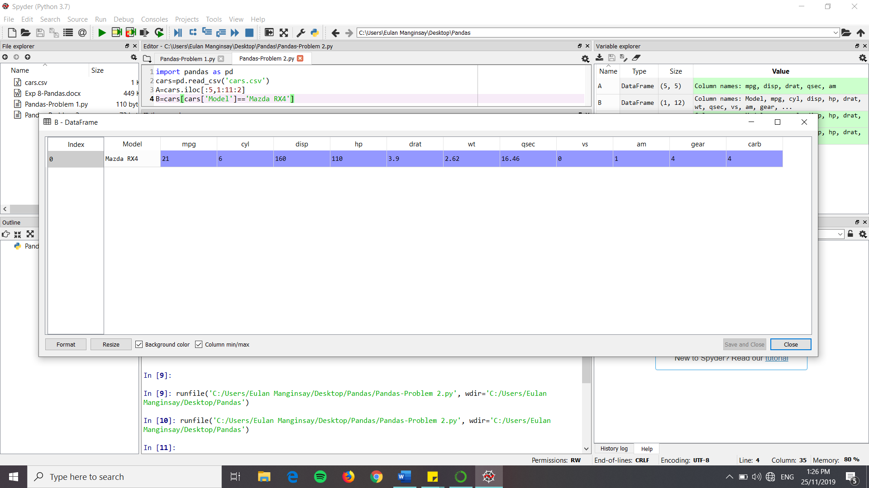

**c.)**

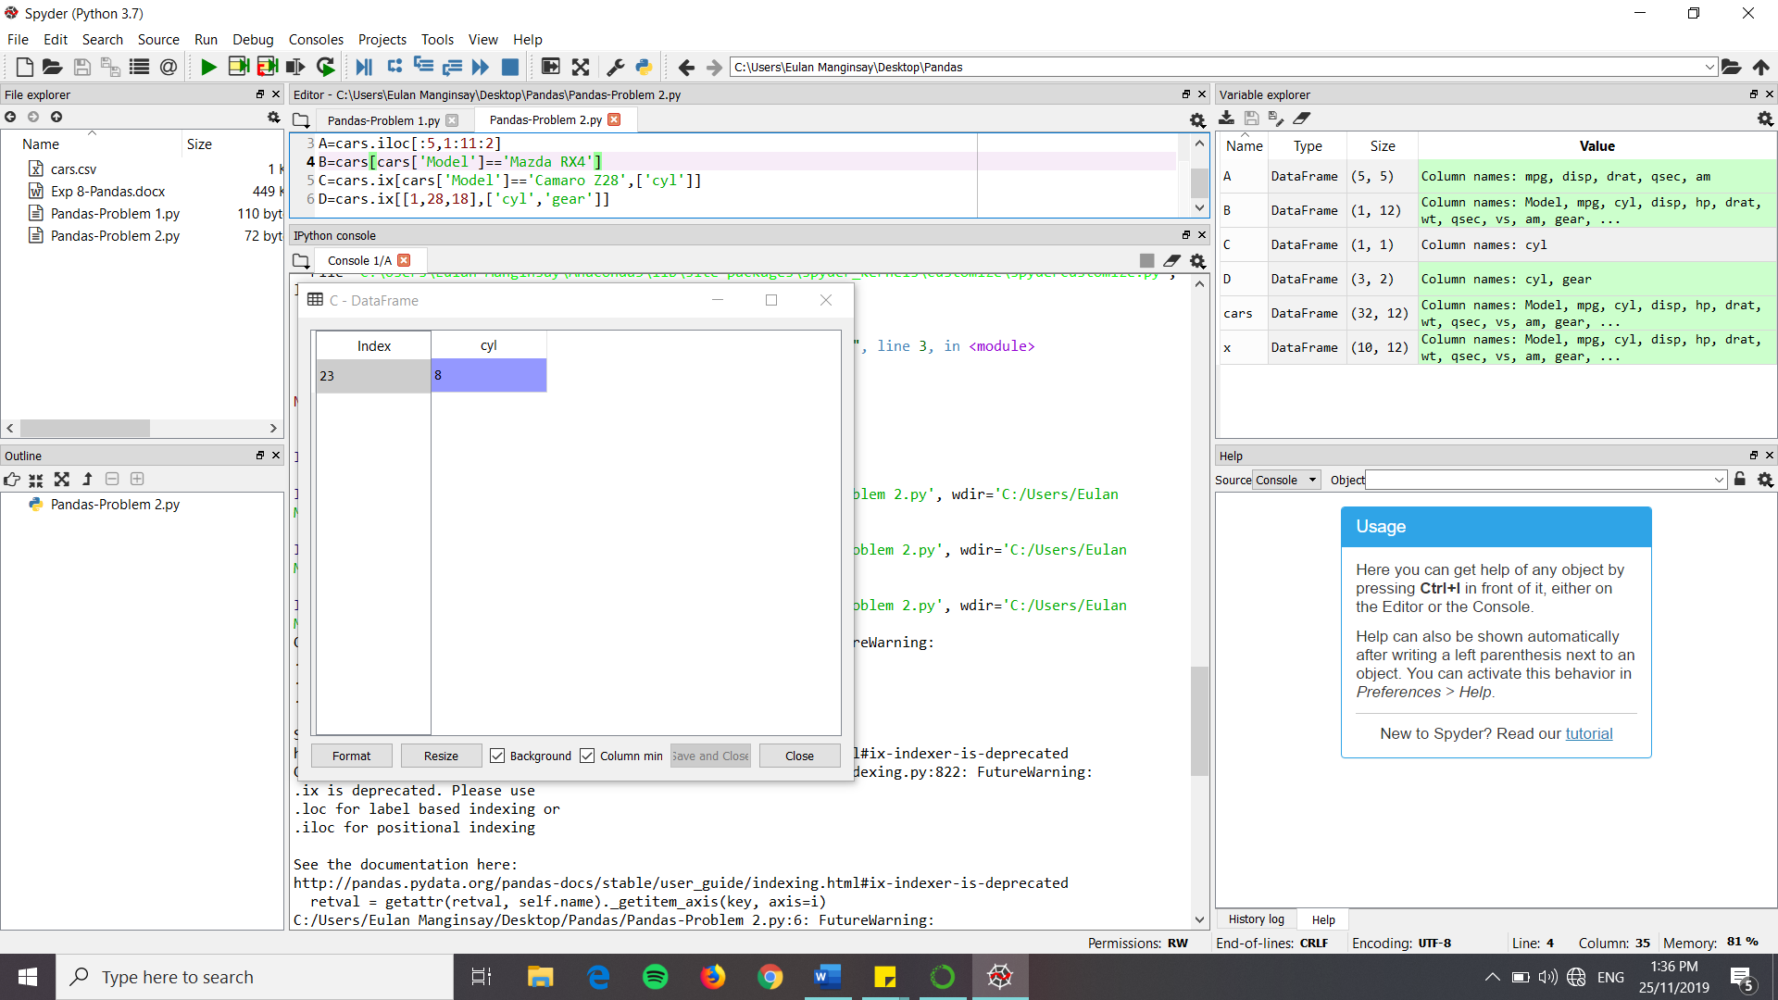

* Camaro Z28 has 8 cylinders.

**d.)**

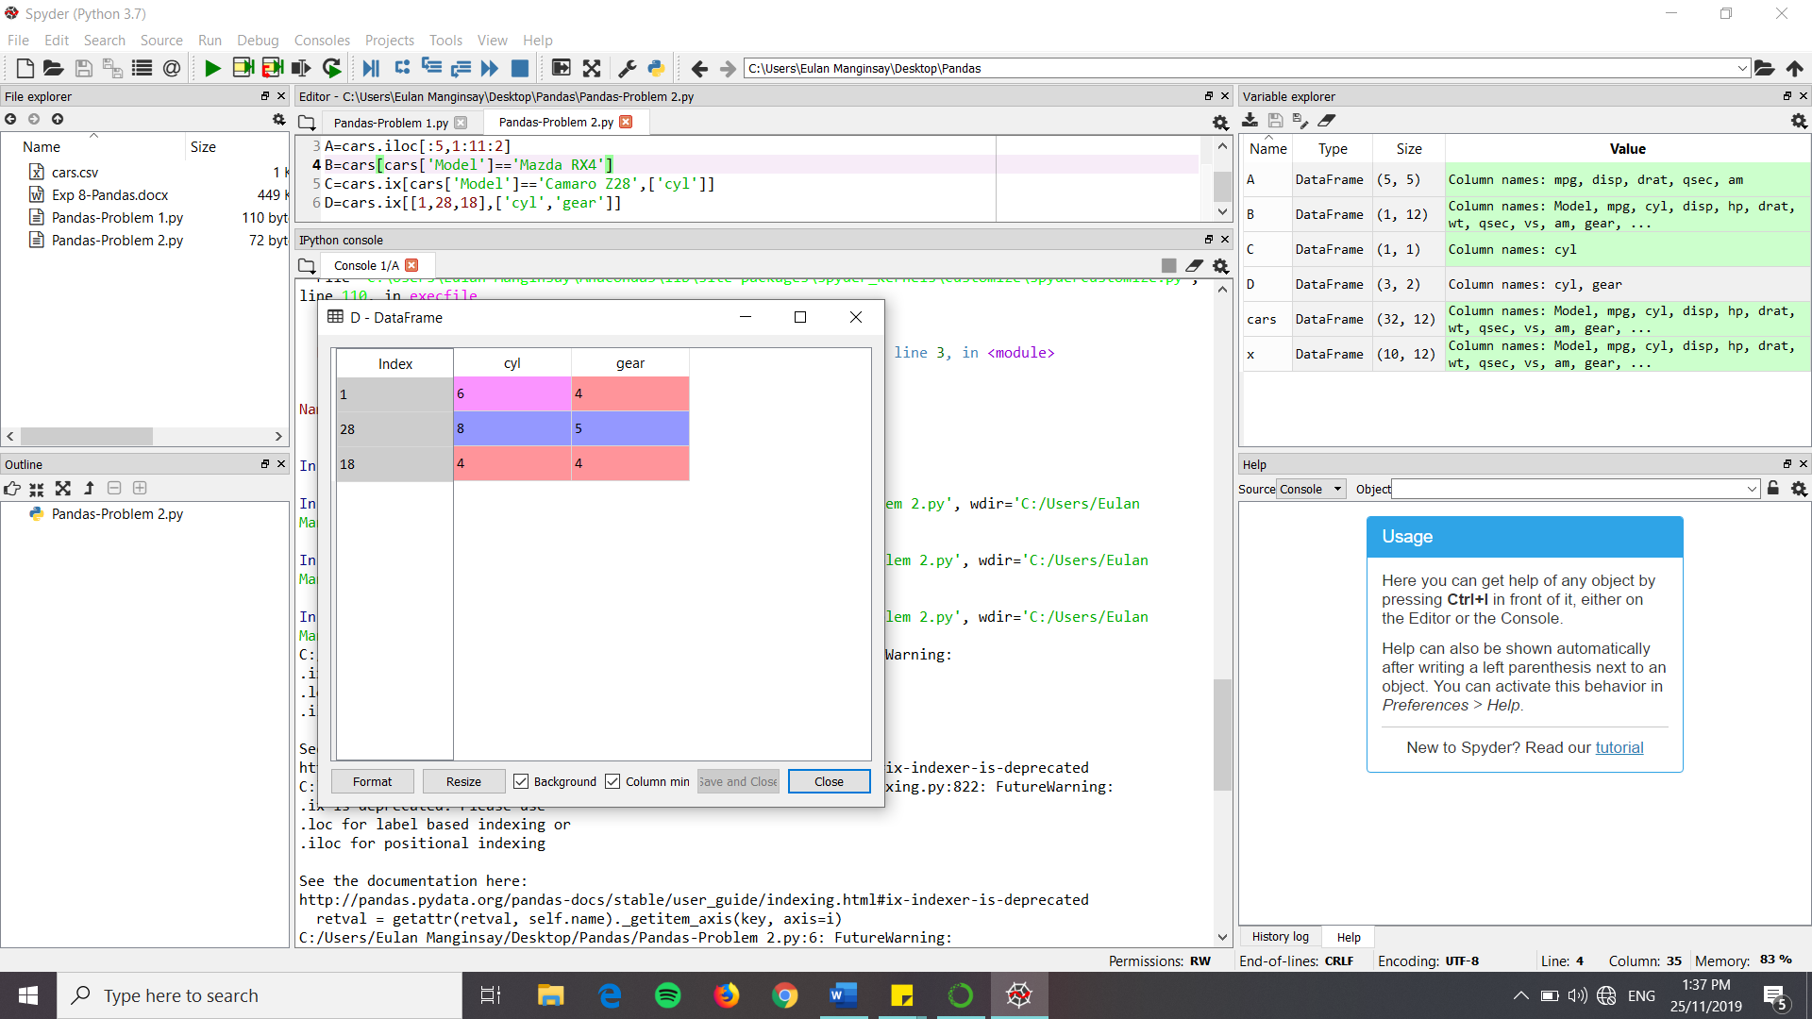

* Mazda RX4 Wag has 6 cylinders and a gear type of 4.

Ford Pantera L has 8 cylinders and a gear type of 5.

Honda Civic has 4 cylinders and a gear type of 4.